A GOOD PLACE

TO LIVE

HOUSING CHOICE VOUCHER PROGRAM (SECTION 8) Housing Quality Standards general requirements

ZANESVILLE METROPOLITAN HOUSING AUTHORITY
Housing Choice Voucher Program (Section 8)
407 Pershing Road Zanesville OH 43701
Office: 740-454-6866 Fax: 740-454-8567

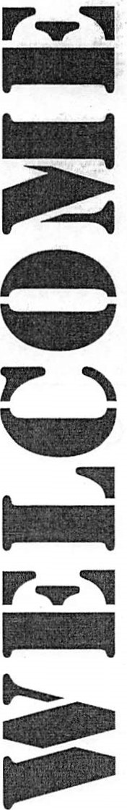
Dear Family,
Having a good place to live is important. Your voucher allows you to choose any house, apartment, duplex or mobile home you like, as long as it meets certain requirements for housing quality, the rent is reasonable, and is located in Muskingum County. This booklet is designed to help you understand what the housing quality standards are and why they are important to you.
Please keep in mind as you are reading this booklet that Housing Quality Standards (HQS) help to insure that your rental will be safe, healthy, and comfortable.
Monday — Thursday | 8:00 am. . —4:00 p.m.
Friday: Due to training and file maintenance we are unable 'to receive phone calls or walk-ins from 11:00 a.m. —4:00 .m. | 8:00 a.m. — 11:00 a.m.
Saturday, Sunday, & Holidays | CLOSED
OFFICE HOURS
CONTENT
Must Haves ……….3 Other Areas…………….11
De Minimus……….4-5 Exterior………………...12
Paint and Cleaning...6 Heating and Plumbing….13
Living Room………7 Health and Safety……....14-15
Bedroom…………...8 Unit Failures…………....16
Kitchen………….....9 What’s Next?....................17
Bathroom…………..10
Most rentals must have at least a living room, kitchen, and bathroom. A one room efficiency apartment with a kitchen area is permissible. However, there must be a separate bathroom for private use for your family. Generally there must be one living/sleeping room for every two family members.
Requirements that apply to the living room, kitchen, bathroom, bedrooms, enclosed porches, finished basements and all other rooms that are lived in.
Ceiling
- A ceiling that is in good condition
- Not acceptable are large cracks or holes that allow drafts, severe bulging, and large amounts of loose or falling surface material such as plaster.
Walls
- Walls that are in good condition
- Not acceptable are large cracks or holes that allow drafts, severe bulging or leaning, large amounts of loose or falling surface material such as plaster.
Locks
- All windows and doors that can be reached from the outside, a common public hallway, a fire escape, porch or other outside place that can be reached from the ground require a lock that works. A window that cannot be opened is acceptable in some instances.
Floor
- A floor that is in good condition.
- Not acceptable are large cracks or holes, missing or warped floorboards or covering that could cause someone to trip.

What Inspectors Are Looking For When Inspecting Units Built Before January 1, 1978, And Occupied Or To Be Occupied By Assisted Families With One Or More Children Under Age Six or a Pregnant Mother:
De Minimis Deteriorated Paint Surfaces Are: 20 square feet on exterior surfaces, 2 square feet on an interior surface in a single room or interior space, or 10 percent of individual small components (e.g., window sills, the complete interior and exterior of the window including between windows when storm windows are present, doors and all trim work, etc.
When deteriorated paint is below the de minimis level: Owners must perform paint stabilization on all deteriorated paint or other coated surfaces larger than small nail holes and small hairline cracks regardless of the location of the deteriorated surface. Paint Stabilization is defined as:
Repair of any physical defect in the substrate of the painted surface or building component. (Examples of defective substrate conditions include dry rot, rust, moisture-related defects, crumbling plaster, missing siding, or other components not securely fastened).
Removal of all loose paint and other loose material from the surface being treated; and a new protective coating applied to the stabilized surface.
In no circumstance many an owner employ any paint stabilization methods strictly prohibited by federal, state, or local law such as:
- Open flame burning and torching;
- Machine sanding or grinding without a high-efficiency particulate air (HEPA) local exhaust control;
- Heat guns operating over 1,100 degrees Fahrenheit;
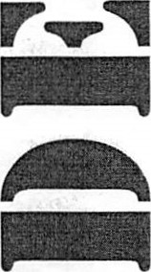
- Abrasive blasting or sandblasting without HEPA exhaust control
- Dry sanding and scraping except within (1) square foot of electrical outlet; and
- Paint stripping in poorly ventilated space using volatile stripper or a hazardous chemical as defined by Occupational Safety and Health Administration (OSHA)
When deteriorated paint is above de minimis level: Owners need to have work performed by qualified individuals. All workers completing this work must be trained or supervised by a certified "Lead-Based Paint Abatement Supervisor". Stabilization activities are not complete until a clearance examination (laboratory results) verifies that the work area/site is clean, this may include soil sampling. Persons who have EPA or state-approved training and are licensed or certified to perform clearance examinations must perform clearance examinations.

Option to Paint Stabilization: Instead of stabilizing all deteriorated paint, the owner has the option, at their own expense, to have all deteriorated paint surfaces tested for lead and then stabilize only the deteriorated paint that contains lead. A lead-based paint inspector or risk assessor certified by an EPA or state-approved agency must do the testing.
Failure to comply with paint stabilization requirement: Regardless of the amount of deteriorated surface, deteriorated surfaces will result in disapproval of the tenancy, abatement of payment to the owner, and/or termination of the HAP contract. The HQS violation for paint stabilization is considered closed when ZMHA receives an executed copy of the Lead-Based Paint Owner's Certification.
Specific Regulations For Units Built Before January 1, 1978, And Occupied Or To Be Occupied By Families With One Or More Children Under Age Six:
- Perform ongoing maintenance. As part of ongoing maintenance, the owner must provide written notice to assisted families asking occupants to report deteriorated paint. The notice must include the name, address, and phone number of the person responsible for accepting the occupant's complaint. See sample letter below.
- Owners are responsible for protection of residents and their belongings during lead-based paint stabilization; this can include relocation to a lead safe unit.
- Owners are required to notify tenants about the conduct of lead hazard reduction activities and clearance results (if required), no more than 15 calendar days after the hazard reduction activities have been completed.
The owner is required to conduct visual assessment for deteriorated paint and failure of any hazard reduction measures at unit turnover and every 12 months of continued occupancy. (After lead hazard reduction above de minimis.)
SAMPLE LETTER
Dear Tenant,
With the new lead paint regulations, I am required to give you written notice that you must report deteriorated paint in your rental unit. Deteriorated paint is to be reported to:

Name: ____________________________________________________
Address: __________________________________________________
Phone Number: _____________________________________________

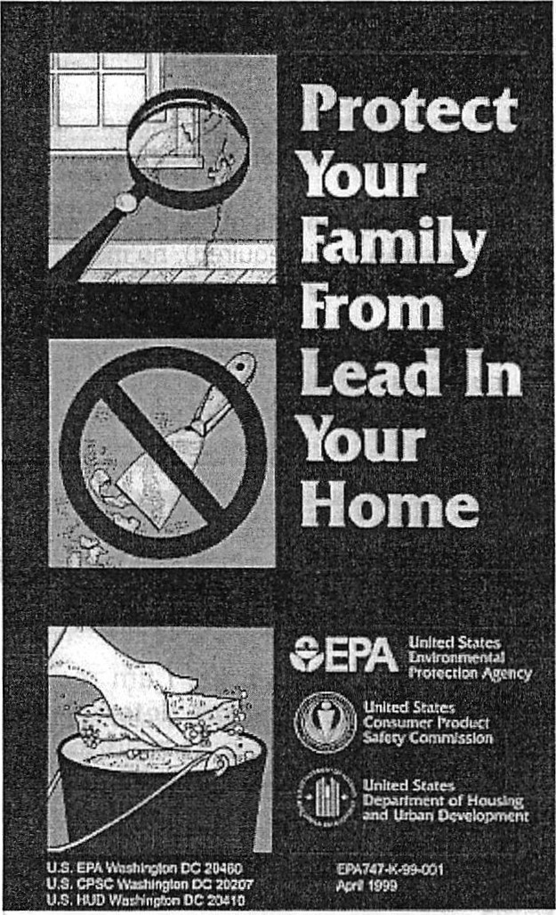
OWNER'S RESPONSIBILITIES
For All Tenants HCVP (Section 8) or Non HCVP
The owner is required to disclose any knowledge of lead-based paint or leadbased paint hazards in housing built prior to January 1, 1978, to all prospective residents.
The owner must also provide all prospective families with a copy of Protect Your Family From Lead In Your Home or other EPA approved document.

THE LIVING ROOM MUST HAVE:
Electricity
At least two separate electric outlets, or one outlet and one permanent ceiling or wall light fixture that works.
- Do not count table or floor lamps, ceiling lamps plugged into a socket, and extension cords; they are not permanent.
- Not acceptable are broken or frayed wiring, light fixtures hanging from wires with no firm support (such as a chain), missing cover plates on switches or outlets, badly cracked outlets.
Window
At least one window. Every window must be in good condition.
- Not acceptable are windows with cracked, broken or missing panes, and windows that do not shut or, when shut, do not keep out the weather.
You Should Also Think About:
- The type of locks on windows and doors. o Are they safe and secure?
- Are windows that you might like to open in working order? The condition of the windows.
- Are there small cracks in the panes?
The amount of weatherization around the doors and windows. o Are there storm windows?
- Is there weather stripping? If you pay for your own utilities, this may be important.
- The location of electric outlets and light fixtures. The condition of the paint and wallpaper. o Are they worn, faded or dirty? The condition of the floor.
- Is it scratched and worn? Is the carpet dirty or worn?
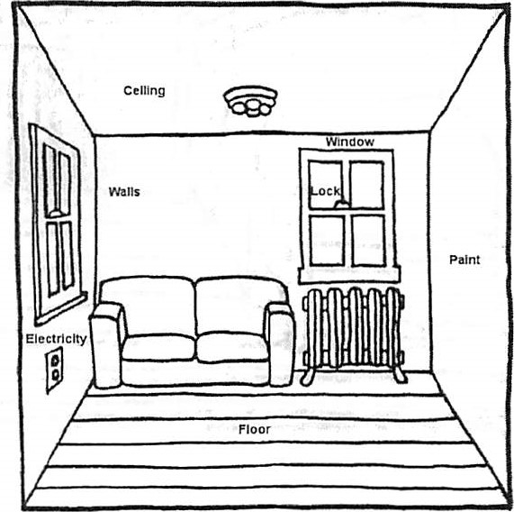
THE BEDROOM(S) MUST HAVE:
Electricity
At least two separate outlets, or one outlet and one permanent ceiling or wall light fixture that works.
- Do not count table or floor lamps, ceiling lamps plugged into a socket, and extension cords; they are not permanent.
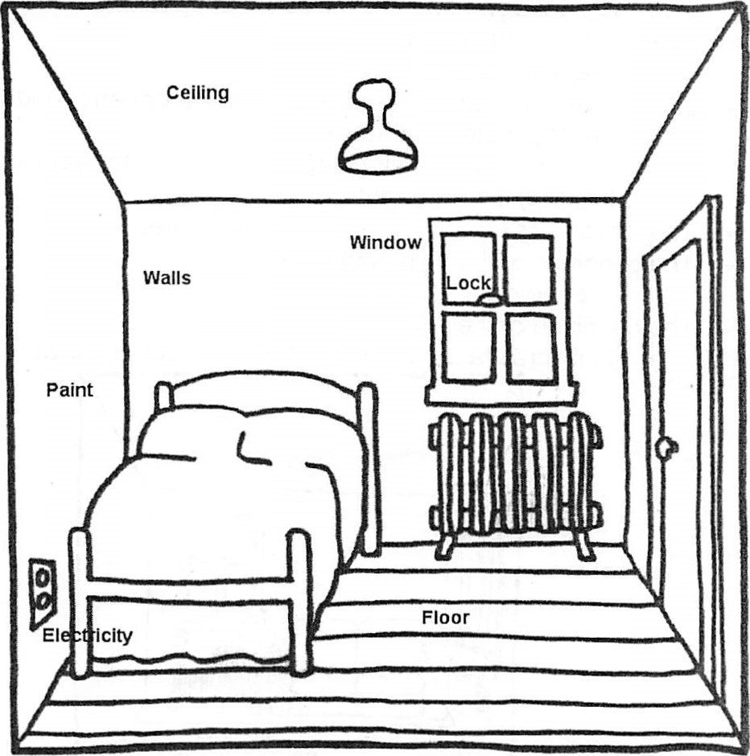
- Not acceptable are broken or frayed wiring, light fixtures hanging from wires with no firm support (such as a chain), missing cover plates on switches or outlets, badly cracked outlets.
Smoke Detectors
The bedroom needs a working smoke detector properly located and in working order. Please check manufactures guidelines before installing.
Windows
At lease one window, which must be able to open to the exterior if it was designed to be opened, in every room used for sleeping.

THE KITCHEN MUST HAVE:
Electricity
At least one electric outlet and one permanent ceiling or wall light fixture that works.
- Do not count table or floor lamps, ceiling lamps plugged into a socket, and extension cords; they are not permanent.
- Not acceptable are broken or frayed wiring, light fixtures hanging from wires with no other firm support (such as a chain), missing cover plates on switches or outlets, badly cracked outlets.
Preparation Area
Some space to prepare food.
Refrigerator
A refrigerator and freezer that keeps temperatures low enough so that food does not spoil. The tenant can supply the refrigerator.
Sink
A sink with hot and cold running water.
• A bathroom sink will not satisfy this requirement for the kitchen.
Stove and Oven
A stove (or range) and oven that works. (This can be supplied by the tenant.) In some cases, a microwave oven may be substituted for a stove (or range) and oven. All burners on the stove must work as well as the oven. All stove knobs must be present.
You should also think about:
- The size of the kitchen.
- The amount, location, and condition of space to store, prepare, and serve food. Is it adequate for the size of your family?
- The size, condition, and location of the refrigerator.
- The size, condition, and location of the sink.
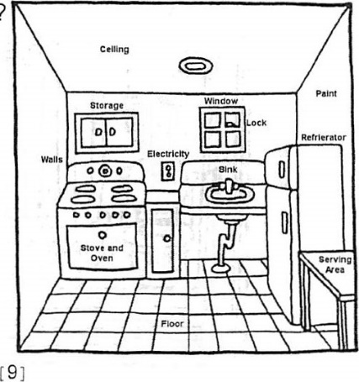
- The number of outlets in the kitchen. Is the floor covering torn or ripped?

THE BATHROOM MUST HAVE:
Electricity
- At least one permanent ceiling or wall light fixture that works.
- Not acceptable are broken or frayed wiring, light fixtures hanging from wires with no other firm support (such as a chain), missing cover plates on switches or outlets, badly cracked outlets.
Sink
- A sink with hot and cold running water.
- A kitchen sink will not satisfy this requirement.
Tub or shower
- A tub or shower with hot and cold running water.
Toilet
- A flush toilet that works
Window
- A window that opens to the exterior or a working exhaust fan for ventilation purposes.
You Should Also Think About:
- The size of the bathroom and the amount of privacy.
- The appearances of the toilet, sink, and shower or tub.
- The appearance of the grout and seal along the floor and where the tub meets the wall.
- The appearance of the floor and walls.
- The size of the hot water heater.
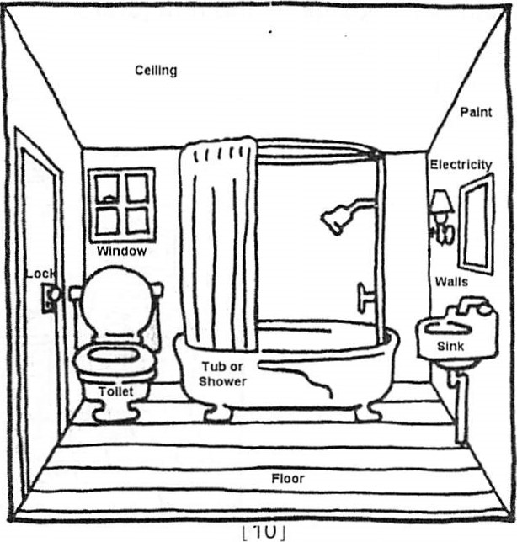
- A cabinet with a mirror.

OTHER AREAS OF THE UNIT
Other areas of the unit that are lived in include: second living room, dens, halls, and finished basements or enclosed porches. The requirements for other rooms that are lived in are similar to the requirements for the living room.
• There is no specific standard for electricity; but there must be either natural illumination (a window) or an electric fixture or outlet.
Other rooms that are not lived in may be.
A utility room for washer or dryer, basement, or porch. These must be checked for security and electrical hazards and other possible dangers (such as walls or ceilings in danger of falling), since these items are important for the safety of your entire dwelling. You should also look for other possible dangers such as large holes in the walls, floors, or ceilings, and unsafe stairways. Make sure to look for these things in all other rooms not lived in.
You Should Also Think About:
- What you would like to do with the other rooms. * Can you use them the way you want to? * The type of locks on windows and doors? * Are they safe and secure?
- Are the windows that you might like to open in working order?
- The condition of the windows. *Are there small cracks in the panes?* The amount of weatherization around doors and windows? *Are there storm windows? *Is there weather-stripping? If you pay your own utilities, this may be important.
- The location of electric outlets and light fixtures.
- The condition of paint and wallpaper.
- The condition of the floors.

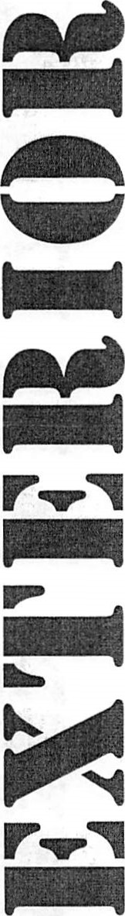
CHIMNEYS
No serious leaning or defects (such as cracks or missing bricks) in any chimneys.

COOLING
Some windows that open, or some working ventilation or cooling equipment that can provide air circulation during warm months.

FOUNDATION
A foundation in good condition that has no serious leaks

OUTSIDE HANDRAILS
Secure handrails on any extended length of stairs (generally three or more steps). A guardrail is needed around porches, balconies, or decks, which are 30 inches or more above ground level. A guardrail must be 36" high and prohibit the passage of a 4" ball.

ROOF
A roof that is in good condition and does not leak. Gutters and downspouts are not required, but if present, are required to be in good condition and securely attached to the building.
Evidence of leaks can usually be seen from stains on the ceiling inside the building.

SEWAGE
A plumbing system that is connected to an approved public or private sewage disposal system.

WALLS
Exterior walls that are in good condition, with no large holes or cracks that would let a great amount of air get inside.

WATER SUPPLY
A plumbing system that is served by an approvable public or private supply system.

HEAT
Enough heating equipment so that the unit can be made comfortably warm during cold months
- Not acceptable are electric portable heaters, space heaters or portable heaters (or room heaters) that burn oil, kerosene, or gas and are not vented to a chimney. Space heaters that are vented may be acceptable if they can provide enough heat. Electric base board heaters are acceptable.
- Furnaces need to be vented properly and can be in living/sleeping rooms as long as there is a divider or walls with a vent.

PLUMBING
Pipes that are in good condition, with no leaks and no serious rust that causes the water to be discolored.

WATER HEATER
A water heater located, equipped, and installed in a safe manner. Hot water tank needs to have a ³/4" discharge pipe ran 3"-6" from the floor. Gas hot water heater must be vented properly and have dividers or walls with vents if present in living/sleeping rooms.
YOU SHOULD ALSO THINK ABOUT:
- How well maintained the exterior of the unit is.
- The type of heating equipment.
- Will it be able to supply enough heat for you in the winter, to all rooms used for living?
- The amount and type of weatherization and its affect on utility cost.
- Is there insulation? Are there storm windows?
- Is there weather-stripping around the windows and doors?

ELECTRICITY
- Electrical splices, including fixtures with open wire connections, must be in junction boxes. Junction boxes must have covers. Electrical wires not in use need to be removed
- Electrical wires cannot be laying on ductwork.
Fuses/ breakers must match wire size. #12 wire=20 amp fuses/ breakers, #14wire=15amp fuses/breakers, etc.
- Fuse/breaker panel must have cover.
- Breaker panel needs to have fillers if breakers are missing.
- Receptacles will be tested to see if there is power to them Grounded receptacles will be tested to see if they are grounded properly. A circuit tester can be purchased at a home improvement store for under $15.00. This tester will check polarity and can tell you if your grounded receptacles are properly grounded, etc.

ELEVATORS
Make sure the elevators are safe, work properly and have an updated elevator inspection certificate.

ENTRANCE
An entrance from the outside or from a public hall, so that it is not necessary to go through anyone else's private apartment to get to the unit FIRE EXITS
The building must provide an alternate means of exit in case of fire (such as fire stairs or exit through window, with the use of a ladder if windows are above the second floor.)

NEIGHBORHOOD
No dangerous places, spaces, or things in the neighborhood such as.
- Nearby buildings that are falling down
- Unprotected cliffs or quarries Fire hazards
- Evidence of flooding

SMOKE DETECTORS
Smoke detectors must be installed in accordance with the current National Fire Protection Association Standards. There must be at least one working smoke detector on each level of the unit, including the basement. If any member of your family is hearing-impaired, the smoke detector must have an alarm system designed for hearing-impaired persons.

GARBAGE
No large piles of trash and garbage inside or outside the unit, or in common areas such as hallways. There must be a space to store garbage (until pickup) that is covered tightly so that rats and other animals cannot get into it. Trash needs to be picked up regularly.
LIGHTS
Lights that work in all common hallways and interior stairs.
POLLUTION
No serious air pollution, such as exhaust fumes or sewer gas.

RODENTS AND VERMIN
No sign of rats or large numbers of mice or vermin (such as roaches).

STAIRS AND HALLWAYS
Interior stairs with railings, and common hallways that are safe and in good condition.
FOR MANUFACTURED HOMES: TIE DOWNS
Manufactured homes must be placed on the site in a stable manner and be free from hazards such as sliding or wind damage.
YOU SHOULD ALSO THINK ABOUT:
- The type of fire exit
- Is it suitable for your family?
- How safe the rental is for your family.
- The presence of screens and storm windows
- Services in the neighborhood. Are there stores nearby? Are there schools nearby? Are there hospitals nearby?
- Is there public transportation nearby?
- Are there job opportunities nearby?
- Will the cost of tenant-paid utilities be affordable and is the unit energy-efficient?

MOST COMMON FAIL ITEMS
- Nonfunctional, missing or improperly located smoke detectors, Must be installed in accordance with current National Fire Protection Association Standards (NFPA)
- Missing or cracked electrical outlet cover plates
- Tripping hazards caused by permanently installed floor coverings
- Cracked or broken windows
- Inoperable stove burners or range hoods
- Missing burner control knobs
- Inoperable bathroom fans or no ventilation in bathroom
- Leaking faucets or plumbing
- No temperature/pressure-relief valve on water heaters
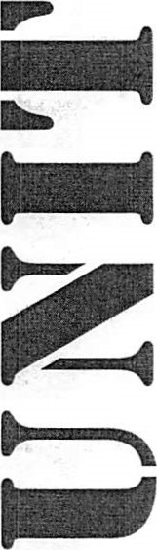
- Improper grounding of electric service, outlets, etc. Wire splices, open wire connections, use of extension cords Hand & guard rails not present where required
- Peeling, cracking or chipping exterior and/or interior paint in unit occupied or to be occupied by child/children under age 6 or pregnant mother

After you find a good place to live, you can begin the Request for Tenancy Approval (RTA) process. You will receive the RTA when all required documentation has been submitted. This form must be submitted to the PHA along with the proposed unexecuted lease if your landlord will not be using our model lease. When the PHA receives your RTA, they will review it to determine if the unit is the correct size and the proposed rent is approvable. If the Request for Tenancy Approval and proposed lease are in order, the PHA will make an appointment to inspect the housing unit. Please note: if the unit is empty please submit a key with the RTA.
Inspection Process
If the unit passes the initial inspection, the PHA will prepare the necessary paperwork and your assistance will begin if you are living there. If the unit fails the initial inspection, you and the owner will be mailed a list of necessary repairs.
There are three ratings for the conditions verified by the Inspector: pass, inconclusive, or fail.
*Pass means the condition meets the minimum requirement.
*Inconclusive means that more information is needed for the inspector to make a determination. For example: Items that are inaccessible or we cannot see, or if the electricity and gas are not in service on the date of inspection, the inspector will mark "inconclusive" until service is turned on and verified.
*Fail means that the condition does not meet the minimum requirement and must be brought up to the standard before the tenant can receive rental assistance on the unit. All fail items must be corrected and approved prior to the execution of the Housing Assistance Payments Contract. If there are major repairs to be made, or if the owner seems reluctant to make the repairs, you may want to consider looking for another unit.
Please Note: The HCVP (Section 8) Department cannot pay any of your rent until the property has been inspected and has passed the inspection. The HCVP (Section 8) Department will begin to pay their share of the rent once the property passes the inspection, you have moved into the property and the utilities are on in your name (or other family member's name), if not owner supplied.
We will not pay rent towards any property that passes inspection on or after the 20th of the month. We will begin to pay rent on the property beginning the first of the following month.
For example: If the rental unit property passes inspection March 20th the
HCVP (Section 8) would not start paying any rent on your behalf until
April 1 ^{st}
Once the Unit Passes Inspection
The PHA will prepare the leasing paperwork. Once prepared the PHA will contact you to take the paperwork to your landlord to sign.

FOR MORE INFORMATION

ZANESVILLE METROPOLITAN HOUSING AUTHORITY
Housing Choice Voucher Program (Section 8)
407 Pershing Road Zanesville OH 43701 Office: 740-454-6866 Fax: 740-454-8567
KENT OR

